**PROJECT: EFFECT OF COMPETITION ON A THREATENED SPECIES, CENTAUREA CORYMBOSA**

*Centaurea corymbosa* is an endemic species of the Clape, in Southern France. It is closely related to other *centaurea* species growing in the same region, but unlike *corymbosa*, these latter are quite abundant. This setting allows finding and understanding the ecological and evolutionary factors that lead *corymbosa* to extinction.

This study aims at estimating the effect of competition on *Centaurea corymbosa*: **is the species threatened because it is not as competitive as the other centaurea species?**

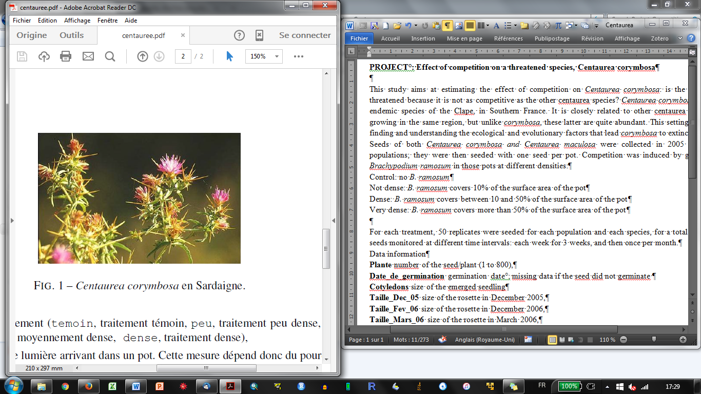

Seeds of both *Centaurea corymbosa and Centaurea maculosa* were collected in 2005 in two populations; they were then seeded with one seed per pot. Competition was induced by growing *Brachypodium ramosum* in those pots at different densities:

Control: no *B. ramosum*

Not dense: *B. ramosum* covers 10% of the surface area of the pot

Dense: *B. ramosum* covers between 10 and 50% of the surface area of the pot

Very dense: *B. ramosum* covers more than 50% of the surface area of the pot

For each treatment, 50 replicates were seeded for each population and each species, for a total of 800 seeds monitored at different time intervals: each week for 3 weeks, and then once per month.

Data information

**Plante** number of the seed/plant (1 to 800)

**Date_de_germination** germination date; missing data if the seed did not germinate

**Cotyledons** size of the emerged seedling

**Taille_Dec_05** size of the rosette in December 2005,

**Taille_Fev_06** size of the rosette in December 2006,

**Taille_Mars_06** size of the rosette in March 2006,

**Taille_Juin_06** size of the rosette in June 2006,

**Taille_Sept_06** size of the rosette in September 2006,

**Traitement** treatment factor

**PAR** quantity of light received by a pot, which depends on the percentage of soil covers ; it is 100% in control pots

**Reference** quantity of light received by a pot where it is not covered. it is 100% in control pots

**Espece** species (mac, C. maculosa, cor, C. corymbosa)

**Pop** population names